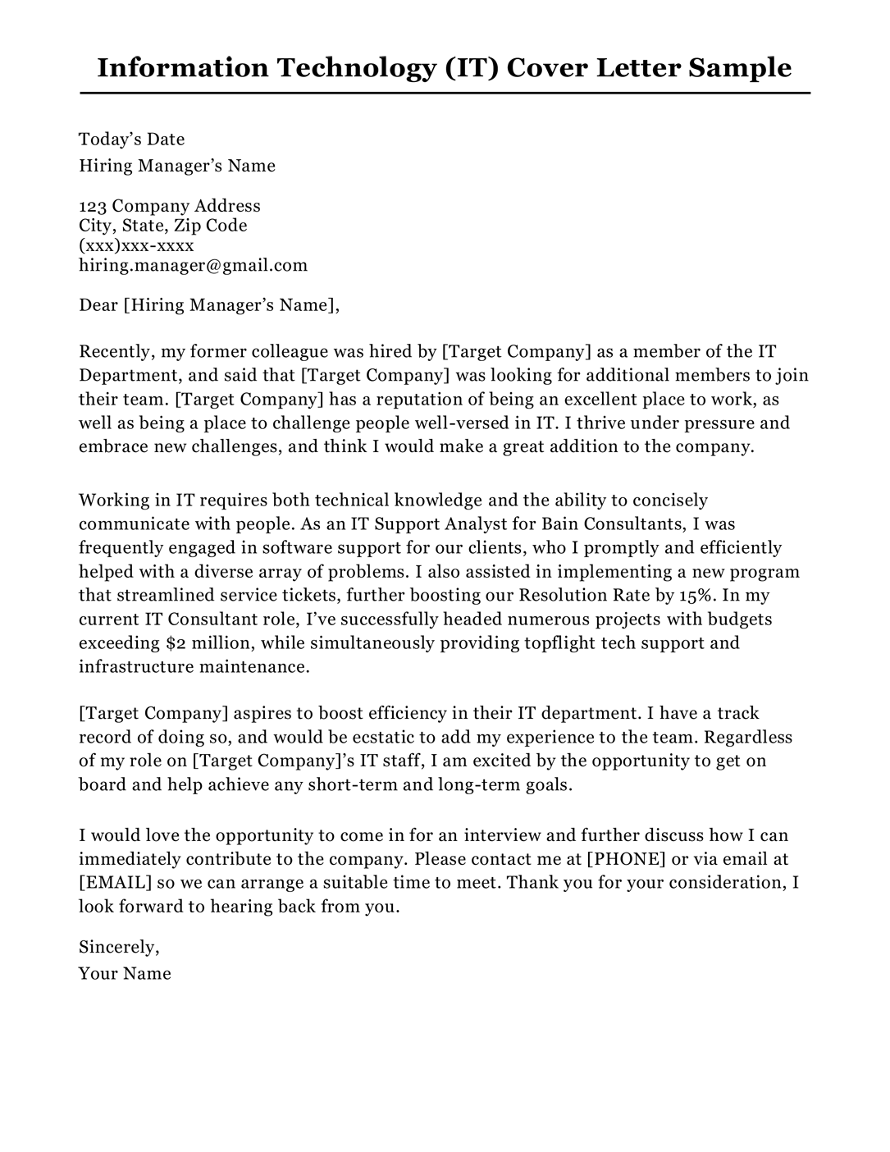
Information Technology (IT) Cover Letter Sample
Today's Date
Hiring Manager's Name
123 Company Address City, State, Zip Code (XXX)XXX-XXXX
hiring.manager@gmail.com
Dear [Hiring Manager's Name],
Recently, my former colleague was hired by [Target Company] as a member of the IT Department, and said that [Target Company] was looking for additional members to join their team. [Target Company] has a reputation of being an excellent place to work, as well as being a place to challenge people well-versed in IT. I thrive under pressure and embrace new challenges, and think I would make a great addition to the company.
Working in IT requires both technical knowledge and the ability to concisely communicate with people. As an IT Support Analyst for Bain Consultants, I was frequently engaged in software support for our clients, who I promptly and efficiently helped with a diverse array of problems. I also assisted in implementing a new program that streamlined service tickets, further boosting our Resolution Rate by 15%. In my current IT Consultant role, I've successfully headed numerous projects with budgets exceeding $2 million, while simultaneously providing topflight tech support and infrastructure maintenance.
[Target Company] aspires to boost efficiency in their IT department. I have a track record of doing so, and would be ecstatic to add my experience to the team. Regardless of my role on [Target Company]'s IT staff, I am excited by the opportunity to get on board and help achieve any short-term and long-term goals.
I would love the opportunity to come in for an interview and further discuss how I can immediately contribute to the company. Please contact me at [PHONE] or via email at [EMAIL] so we can arrange a suitable time to meet. Thank you for your consideration, I look forward to hearing back from you.
Sincerely,
Your Name

